**Details of your portfolio**

PD URL site *(*Compulsory to fill up for milestone 2 and 3):*

*Live link/URL of your PD site*

<https://medicalnerd.github.io/PD-Website/>

Name of your portfolio:

*Your name*

*Goh Yoon Long*

Your Logo:

*Insert your logo*



Describe your target audience:

*Who they are? Describe the demographics of your audience that matter such as age, nationality, race, geographic location, dis/abilities, income level, education level, gender, and sexuality. Describe the psychographics of your audience that matter such as their values, beliefs, and positions, and background knowledge about your topic.*

*Age : Grown-ups in their mid 30s and Young Adults in their 20s.*

*Nationality : Doesn’t matter*

*Race : Doesn’t matter*

*Geographic Location: Global*

*Income Level: Big Business , Start ups , Organisation (Mid – High Income level)*

*Education level: Degree*

*Gender and Sexuality : Any*

*Psychographics:*

*Values and Beliefs: Innovation, effectiveness, and user-centric. Prepared to spend money on high-quality design and development because design and great programming can propel businesses to success.*

*Background Information: Does not have deep understanding of UI/UX design and programming.*

*Goals: To enhance the user experience, their software's general functionality, and online presence , to improve UI/UX , increase user engagement, or streamline internal procedures.*

*Focuses: e-commerce, technology, finance, healthcare, and more.*

*Any nationality, race , mainly Asia Europe.*

Describe your brand story/ purpose:

*Write a short summary of yourself. E.g. Who you are, your inspiration to be (graphics designer/developer/etc), something that interest your target audience, etc*

*Yoon Long became a design genius in a world driven by pixels and passion by fusing creativity with technology. Yoon Long’s quest for UI/UX perfection was relentlessly driven by an unquenchable curiosity that started their adventure.*

*Yoon Long was immersed in the practice of user-centric design right away. Yoon Long insatiable curiosity enabled them to perfect the subtle balancing act between aesthetics and usefulness, producing user-immersive experiences.*

*Every project evolved into an adventure, an investigation into empathy and a celebration of user joy. Yoon Long had the unusual ability to simplify complicated problems into clear answers, making a lasting impression on both brands and people.*

*Yoon Long continues to be a light of innovation, reminding us all that design is more than just pixels—it's the craft of making technology a true companion on life's digital journey. In a world that yearns for seamless interactions.*

**Design brief**

Colour scheme & Colour palette:

*Which colour scheme you have selected for your website? Analogues? Complementary? Triadic? Monochromatic? What are the colours in your colour palette?*

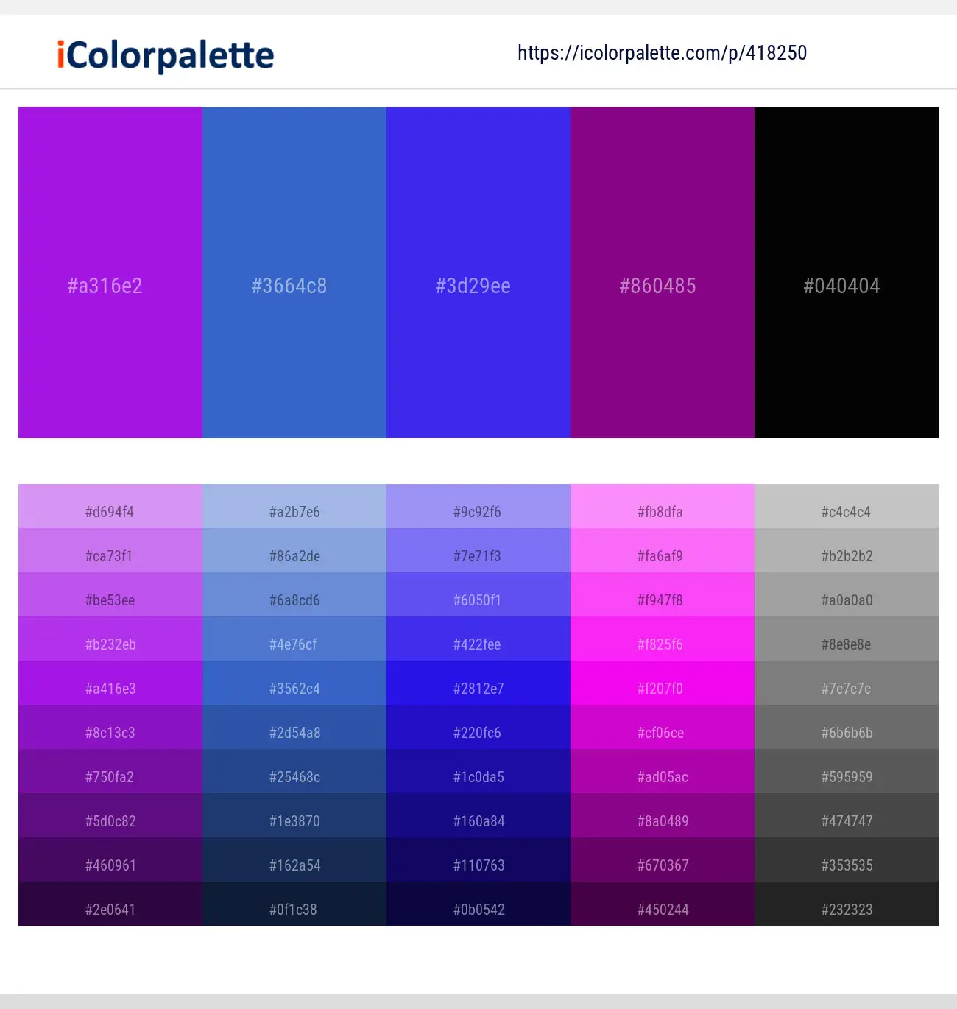

Typography:

*What is the fonts type used?*

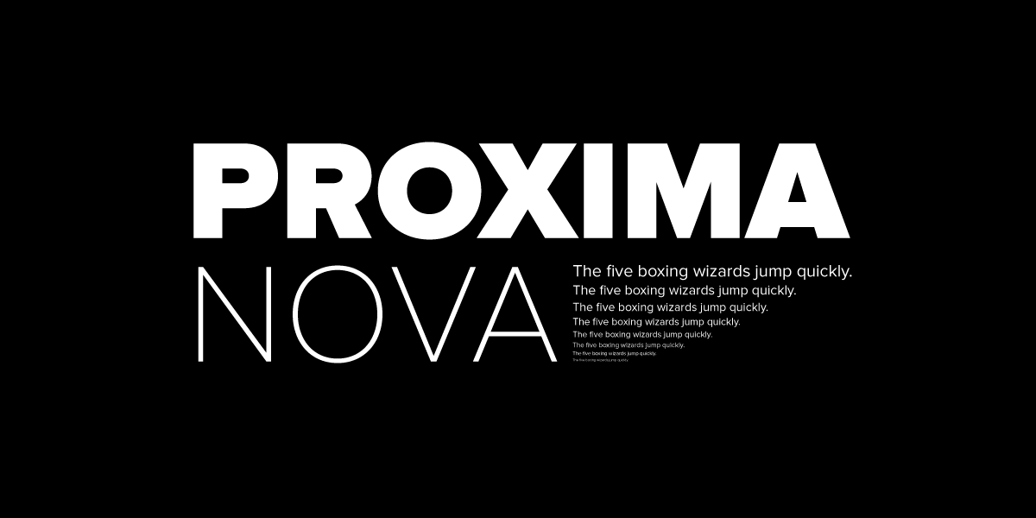

Promixa Nova

Modern and Clean : Promixa Nova typeface is clean and simple with a professional hint to it. It combines the design of sans serif fonts with a more humanist design to it that makes it applicable to a wide range of platforms or resolution.

Legibility : Promixa nova makes it so it can fit well with different screen resolution due to it’s well crafted letterforms and with it’s well balanced proportion, it is the perfect font to use for a mobile app.

Flexibility : Promixa nova comes in multiple different styles and weights like regular , bold , light , semibold and italics. This allows me to use it differently for different parts of the app which will help create a better visual hierarchy and help the user tell the differences between certain contents of the app.

Theme:

*Minimalistic? Contemporary? Fantasy? Sci-fi?*

*Minimalistic*

Layout/ Arrangement:

*How will you arrange the multimodal composition in a way that makes sense for your audience and your purpose? How might you arrange ideas and elements so that your composition is effective?*

***Minimally 3 tabs with 2 layers of navigation***

Opening page

Home

About

Contact

Portfolio

**Low fidelity wireframe:**

*Insert your low-fidelity wireframe here. This can be photo of your sketches or digitally created low-fidelity wireframe using shapes. E.g.*

**High fidelity wireframe** *(*Compulsory to fill up for milestone 2 and 3)***:**

*Insert your high-fidelity wireframe here. Full set of ALL the pages in JPEG or PDF format.*

*E.g.*

**Link in XD for your Prototype (make sure your lecturer is given access to the site)** *(*Compulsory to fill up for milestone 2 and 3)***:**

*Insert your XD link here*

[*https://xd.adobe.com/view/0327438a-3f20-48c6-ac4d-86ee56f08b1a-5674/*](https://xd.adobe.com/view/0327438a-3f20-48c6-ac4d-86ee56f08b1a-5674/)

[**https://medicalnerd.github.io/PD-Website/**](https://medicalnerd.github.io/PD-Website/)

**Reference sites** *(*Optional)***:**

*Any reference websites you have make references*

[**https://youtu.be/Xh-wIMqohD0?si=yRQD_A-RV30JBkHF**](https://youtu.be/Xh-wIMqohD0?si=yRQD_A-RV30JBkHF)